

**OBJECT ORIENTED PROGRAMMING**

**CSL-210**

**Project Report**

# “MATCH TICKET BOOKING SYSTEM”

**Class: BS(CS)-2B**

**Course Teacher: Miss Sameena Javed**

**Lab Teacher: Miss Salas Akbar**

**Group Members:**

Muhammad Isam (02-134221-045)

Zobia Gul (02-134221-064)

Sofia Haider(02-134221-090)

**Table of Contents**

01. Introduction to system 2

02. Database Explanation 3-4

03. Flowchart and UML 5-6

04. Screenshot of forms 7-31

05. Code Snippets 32-62

06. Conclusion 63

1. **INTRODUCTION TO SYSTEM:**

With this project, manual effort is minimized. All stadiums located throughout will be accessible through the online ticket booking system. The user will be able to reserve tickets and pay for a specific game online, saving time by avoiding travelling to the stadium and standing in line. Having a website makes it simpler for customers to make reservations and get information about the upcoming match and seating options. The user and the staff members of the company will find this project to be very user-friendly and highly developed.

It provides the following service:

Login form for admin. Through which admin could change and edit details.

The online cricket booking system is a website that the creators and the proprietor may easily use. Users can get information on match specifics, ticket prices and availability, schedules, stadium locations, and seat information. As the system offers consumers around-the-clock support, they may check reviews and reserve their tickets whenever they want. Additionally, there is the choice to reserve VIP seats.

The major objective of the online match ticket ordering system is to give the customer a location to control the whole ordering process from a single web page. Additionally, it provides consumers with a variety of advantages. They can complete their tickets for any event anywhere and examine the specifics of a match at any moment.

1. **DATABASE EXPLANATION:**

The class ConnectionToDB consists of method for connection of database. The class ConnectionToDB contain a method EstabilishConnection() which is called in every class which needs to be connected with data base.

The method EstabilishConnection() consists of complete path for access files. After giving the path of UcanAccess we have concatenated the location of our Access files.

In the methods adminLogin() we pass a query to select all data from the table in access database(tbl_admin). The method type is Boolean which returns true if the login data matches the data in the access database and allow the following users to work on their respective pages.

The methods addTournament(), addGround(), addEnclosure(), addMatchDetails() in Admin classContain query for inserting data which is passed to these methods, into data base. These methods get the data from GUI txt fields and add respective data to respective tables in data base.

The methods deleteTournament(), deleteGround(), deleteEnclosure(), deleteMatchDetails() in Admin class contain query to delete respective data from the data base on the basis of values passed to these methods from GUI text fields.

The methods searchTournament(), searchGround(), searchEnclosure(), searchMatchDetails() in Admin class contain query to search respective data from tables in data base and display the required data through JOptionPane.ShowMessage() function.

The methods updateTournament(), updateGround(), updateEnclosure(), updateMatchDetails() and updateResult() in Admin class contain query to update the data which is already existing in data base. These methods take data from GUI text fields and replace with the already existing data in data base in respective tables.

The method getEnclosureData() in Enclosure class reads the data from data base and stores it in the respective variables of enclosure class then these variables are added to an array list and the function/method returns an array list of all the data read and stored.

The method getData() in Ground class reads the data from data base and stores it in the respective variables of ground class then these variables are added to an array list and the function/method returns an array list of all the data read and stored.

Group class contains two methods getGroupATeams() and getGroupBTeams(). These both methods read the data from data base tables’ tbl_teama and tbl_teamb and store the data into and array list and return array list.

MatchDetails class contains a method getFinalWinner() searches the data on the basis of genere from tbl_matchdetails in data base and decides the winner team from the third match of knockout stage.

getSeriesData() in MatchDetails class , searches for the data from tbl_matchdetails in data base where genere of the match is Series and and stores it into an array list of series.

getTournamentData()in MatchDetails class , searches for the data from tbl_matchdetails in data base where genere of the match is Tournament and stores it into array list of tournament.

Tournament class contains method getTournamentData()class reads the data from data base and stores it in the respective variables of tournament class.

Ticket class contains methods; generateSeatNo(), getUnavailableRows(), addTicketToTable(), checkSeatCapacity() which contain query to read data frob tbl_ticket in data base and perform the assigned tasks respectively.

Class PointsTable contains getDataPTA() which contains query to search from tbl_pointstableA read all the data and store it into an array list of points table of group A similarly getDataPTB()contains query to search from tbl_pointstableB read all the data and store it into an array list of points table of group B.

3. **FLOWCHART AND UML ::DIAGRAM:**

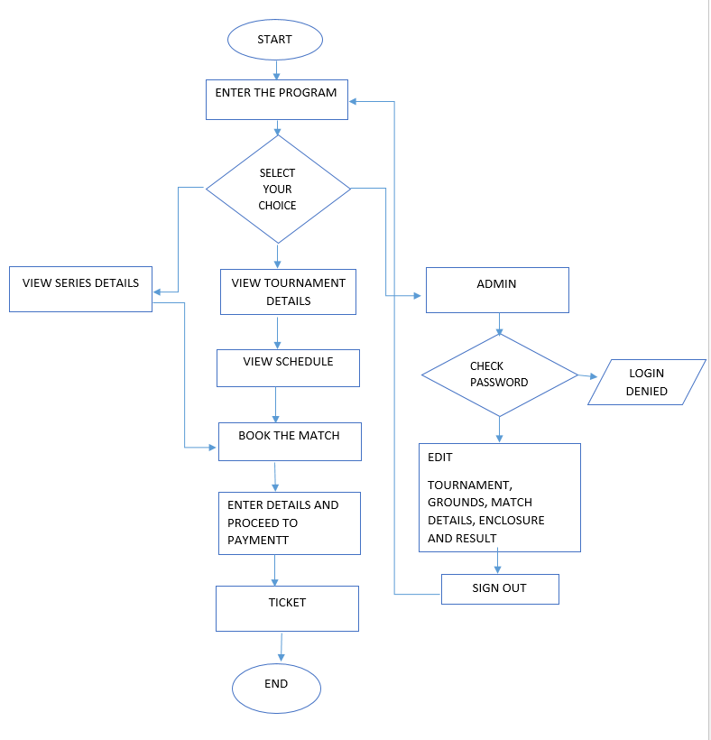

**UML**

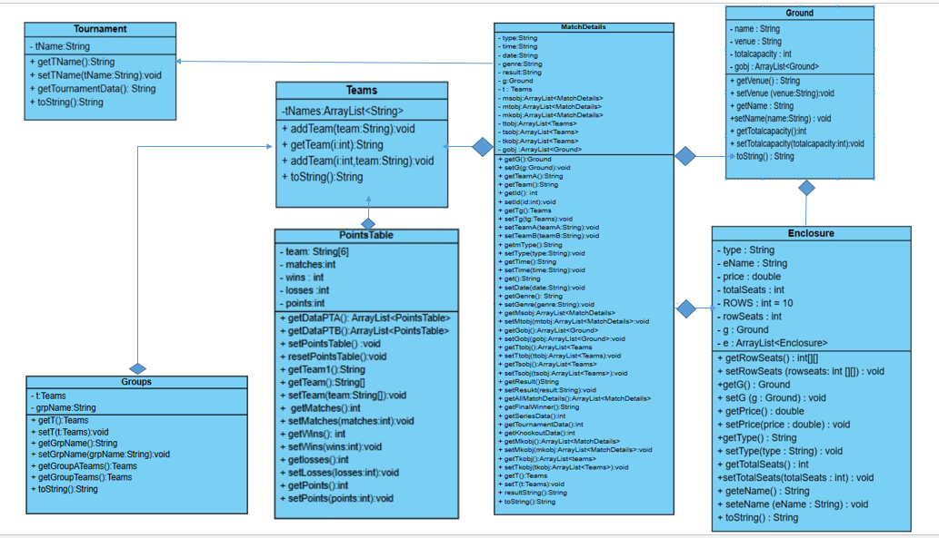

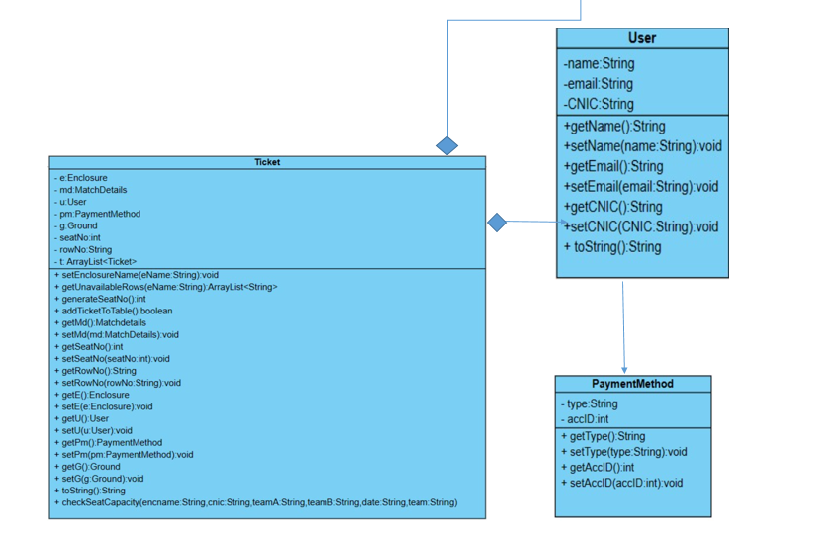

1. **SCREENSHOT OF ALL FORMS:**

**Home Page:**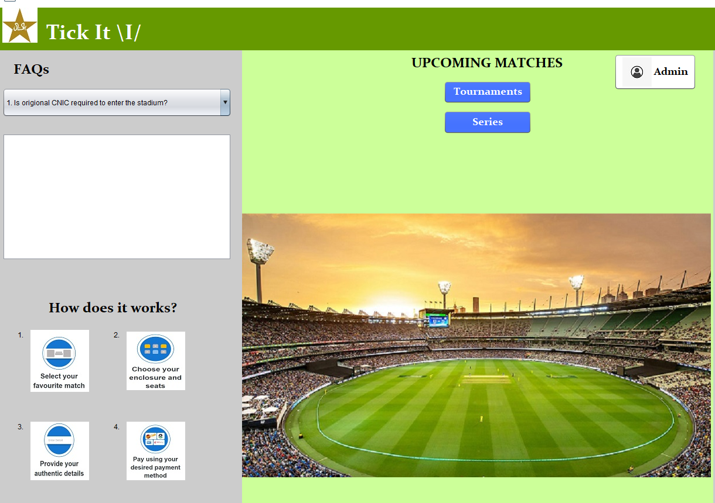

**Figure 4.1-** Main page to access

**FAQS:**

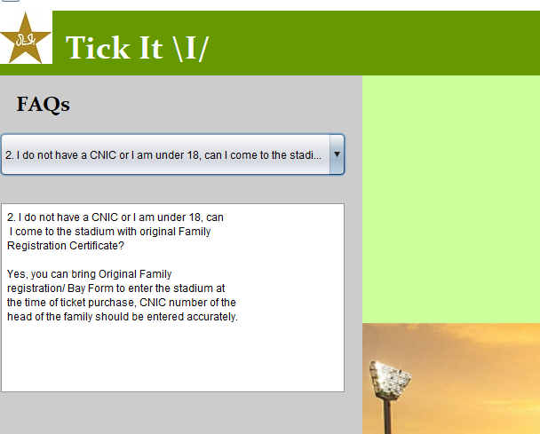

**Figure 4.2-** Customer can choose either of the question, the answer will be provided in the box

**Tournament Groups:**

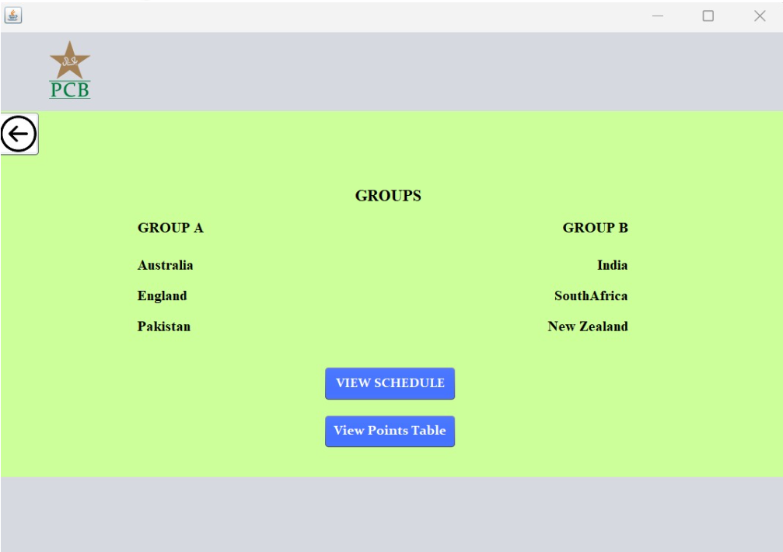

**Figure 4.3-** Tournament Group Show the groups of the team playing or played in the tournament

**Tournament Schedule:**

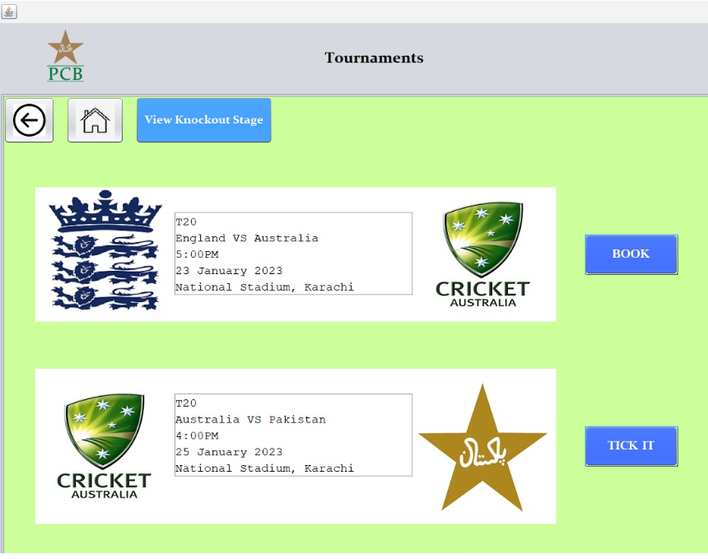

**Figure 4.3-** Tournament schedule shows the available tournaments which can be booked with date, time and venue.

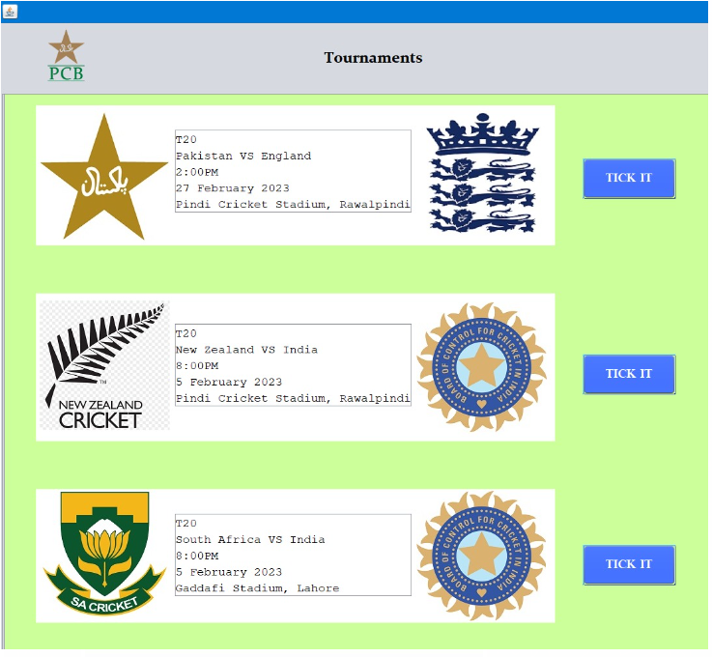

**Figure 4.4-** Tournament schedule shows the available tournaments which can be booked with date, time and venue.

**Points Table:**

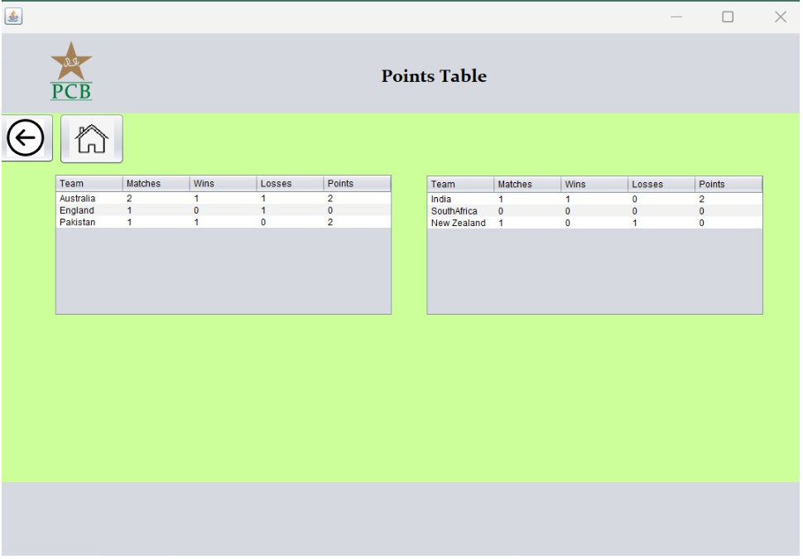

**Figure 4.5-** The total points of the team will be in the form of table

**User Information:**

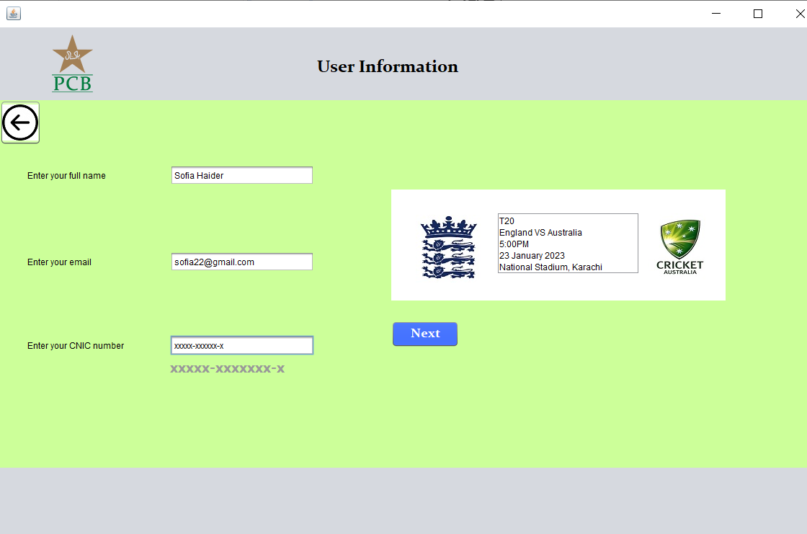

**Figure 4.6-** The user will type their information which includes name, email and CNIC number

**Payment Details:**

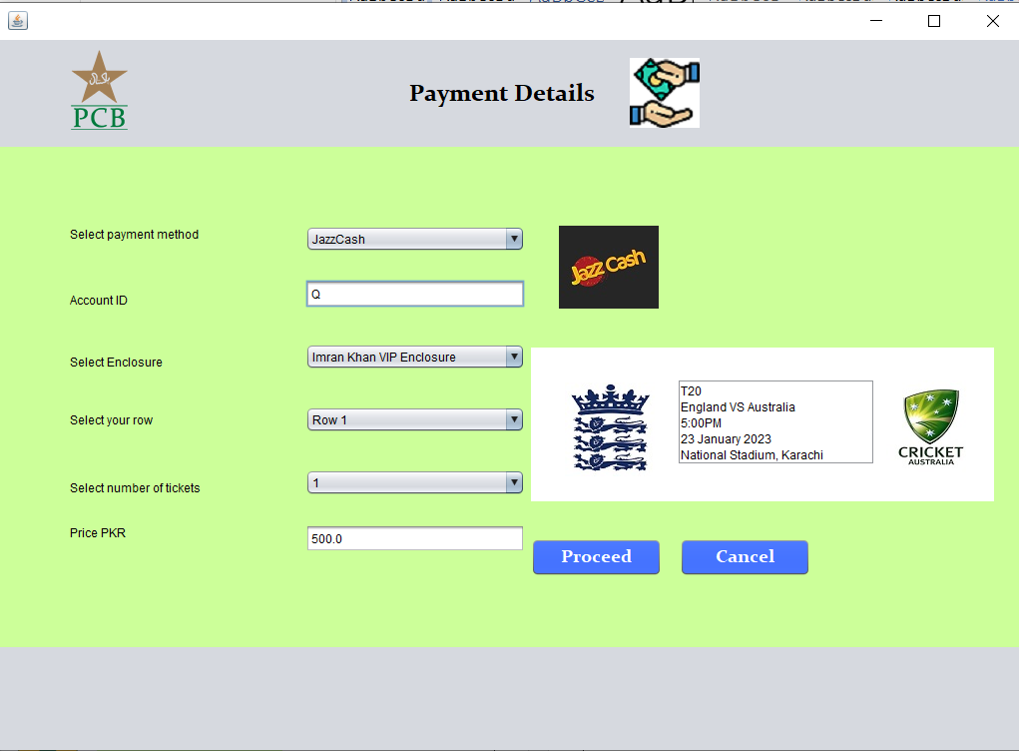

**Figure 4.6-** Payment details asks user to enter payment method, account details ,select enclosure and rows and number of tickets to be bought.

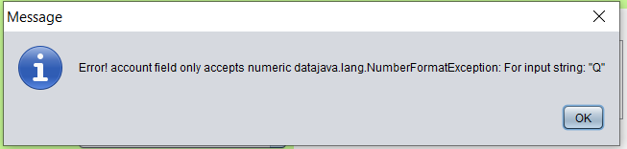

**Figure 4.7-** Exception thrown because the account details only accepts numeric data.

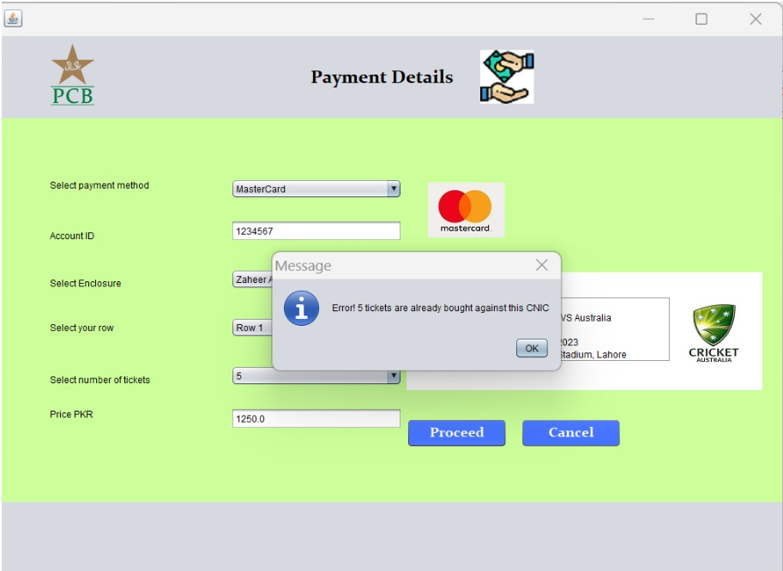

**Figure 4.8-** Exception thrown because more than 5 tickets cannot be purchased on a single CNIC.

**Ticket:**

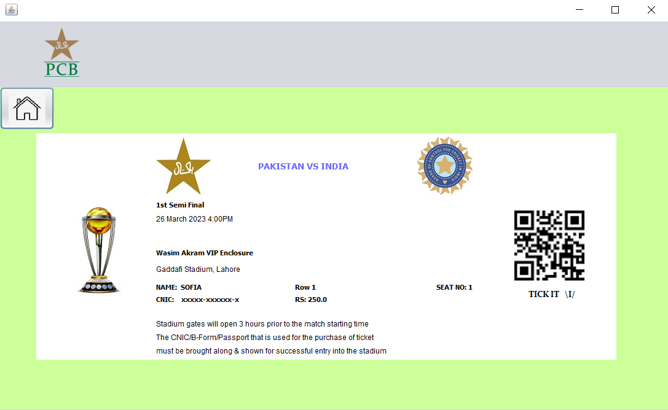

**Figure 4.9-** After the user chooses all the options, a ticket is shown containing the all of the information regarding seat number day, date and venue of the match. Each ticket contains different seat number.

**Series:**

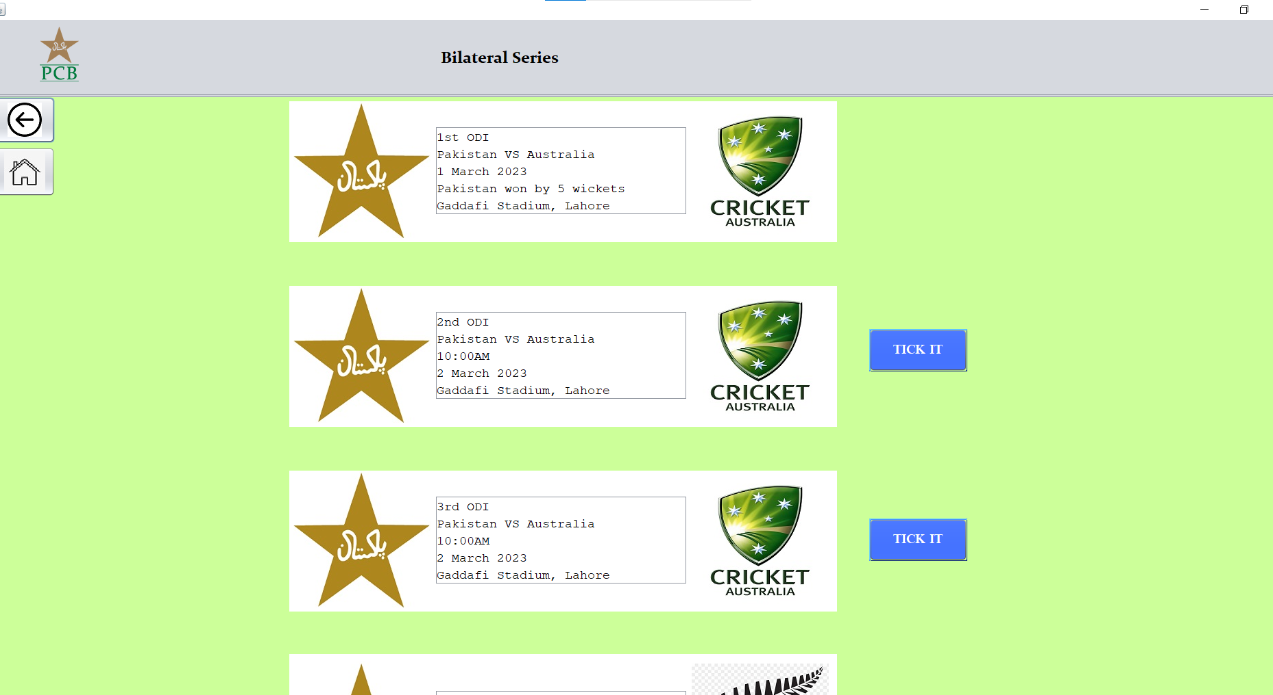

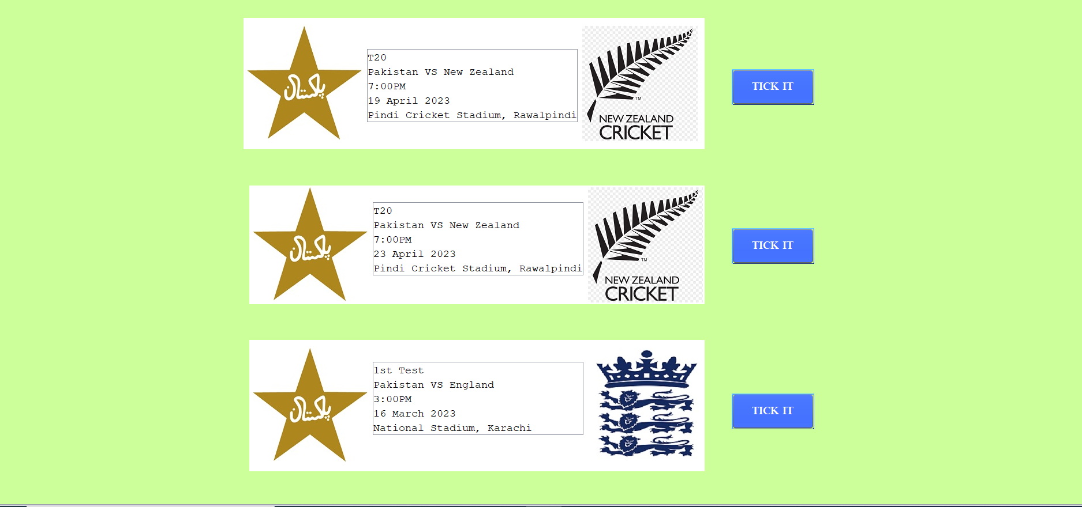

**Figure 4.10-** The series of the matches will be shown

**Ticket:**

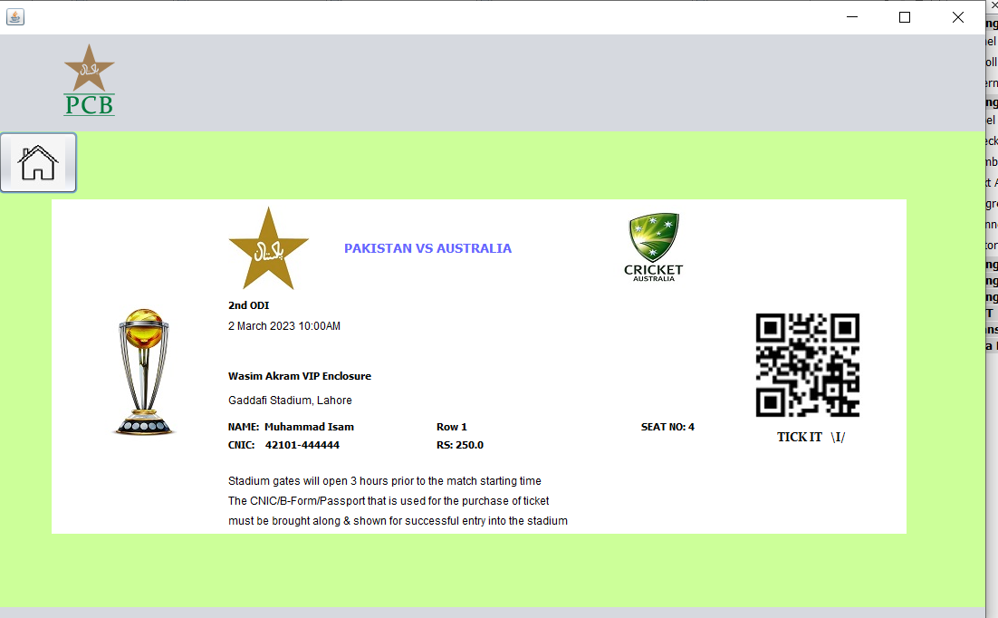

**Figure 4.11-** After the user chooses all the options, a ticket is shown containing the all of the information regarding seat number day, date and venue of the match. Each ticket contains different seat number.

**Admin Login:**

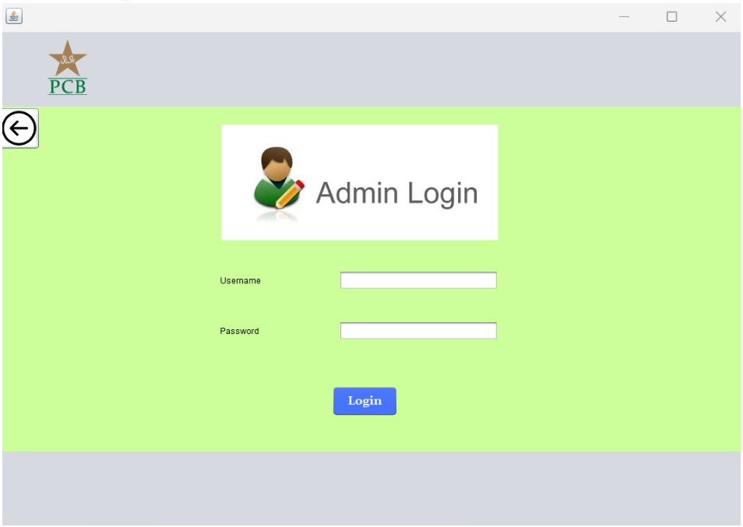

**Figure 4.12-** This is for the admin to login into the system, the admin with enter his username and password, which would be checked at the back hand by database.

**Admin Dashboard:**

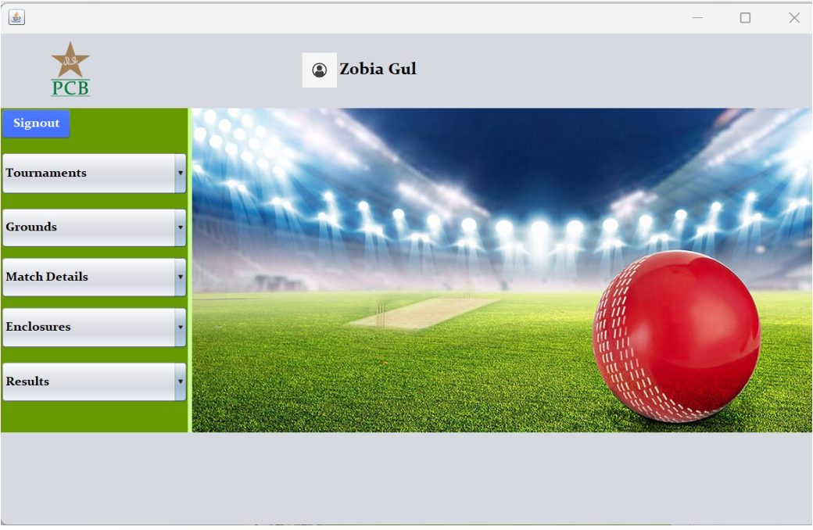

**Figure 4.13-** The admin have access to perform CRUD operations on Tournaments, Ground, Match Details, Enclosures and results. The dashboard shows the name of the particular admin logged in.

**Add Operation (Tournament):**

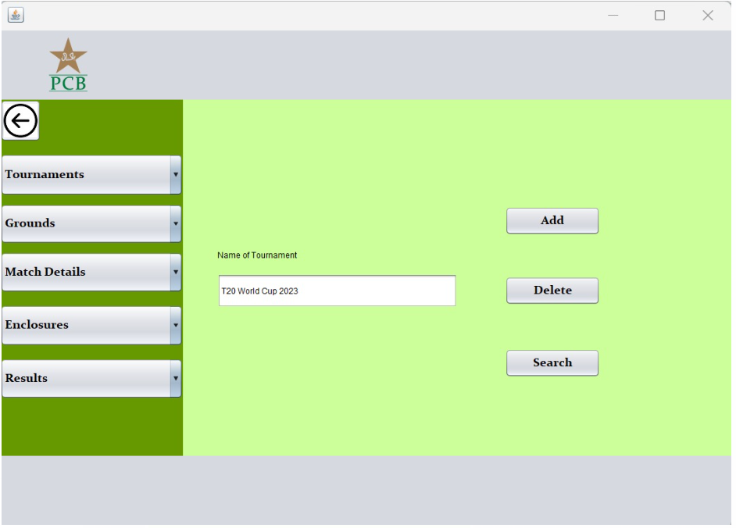

**Figure 4.14-** shows enclosure being added to database by admin by means of Tournament name.

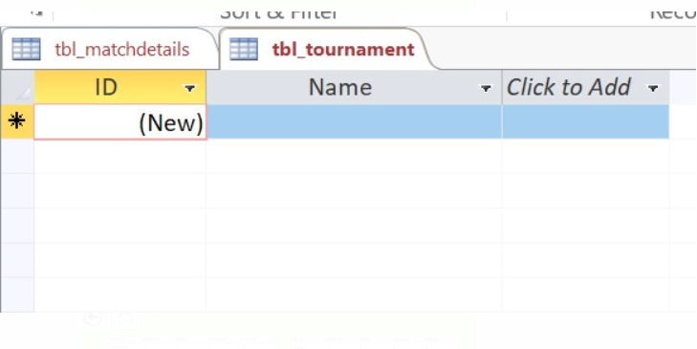

**Figure 4.15-** Database before adding tournament

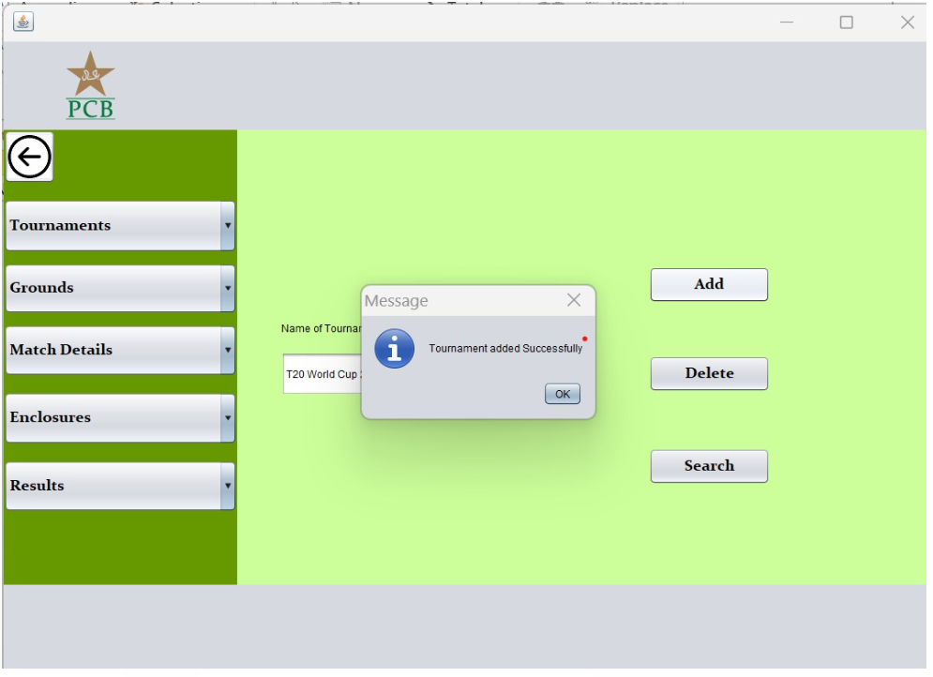

**Figure 4.16-** Tournament added

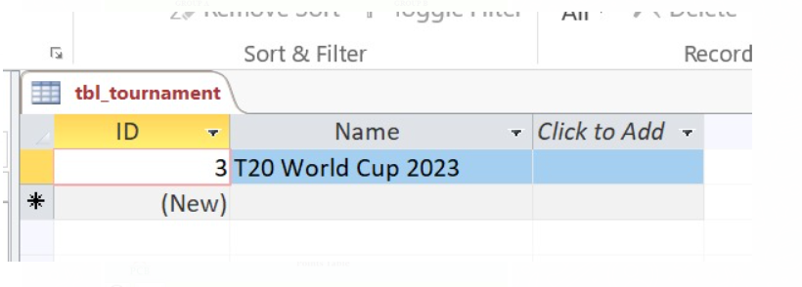**Figure 4.17-** Database after adding tournament

**Search Operation (Tournament):**

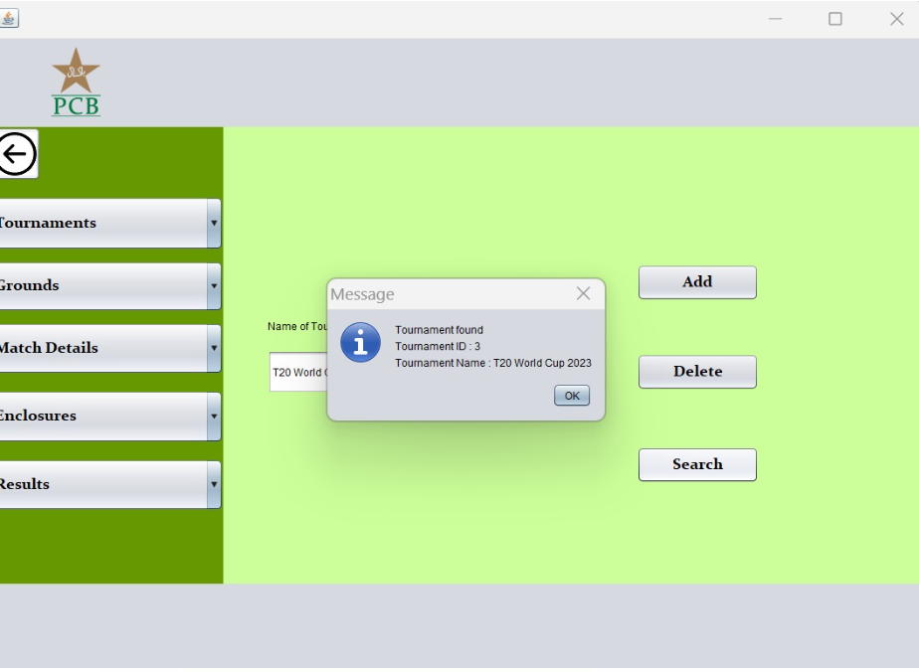

**Figure 4.18-** Message dialogue displays the information of the tournament from data base which was searched.

**Update Operation:**

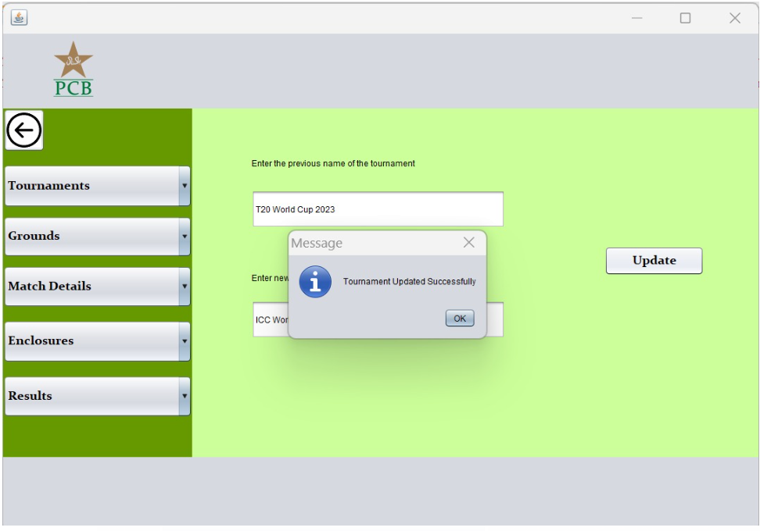

**Figure 4.19-** Tournament being updated in database, by name.

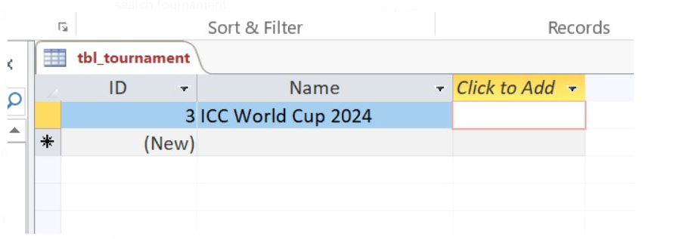**Figure 4.20-** Database after updating tournament

**Delete Operation:**

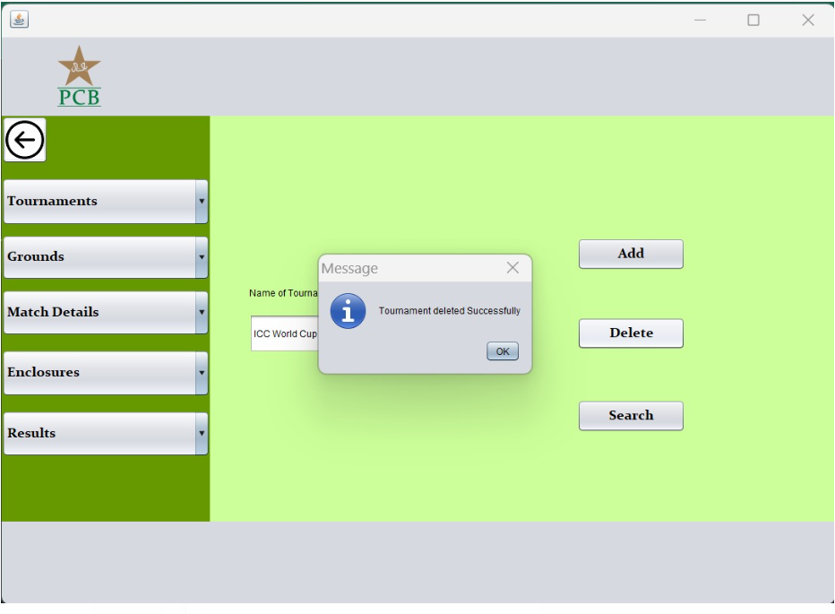

**Figure 4.21-** Tournament being deleted from database by name.

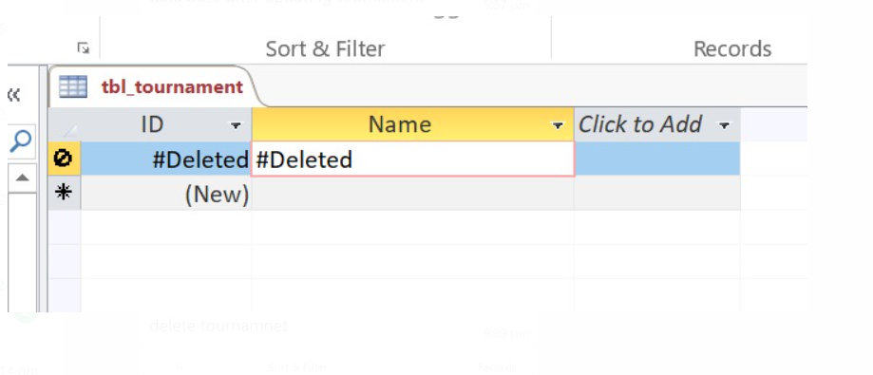

**Figure 4.22-** Database after deleting tournament.

**Update Result of a match:**

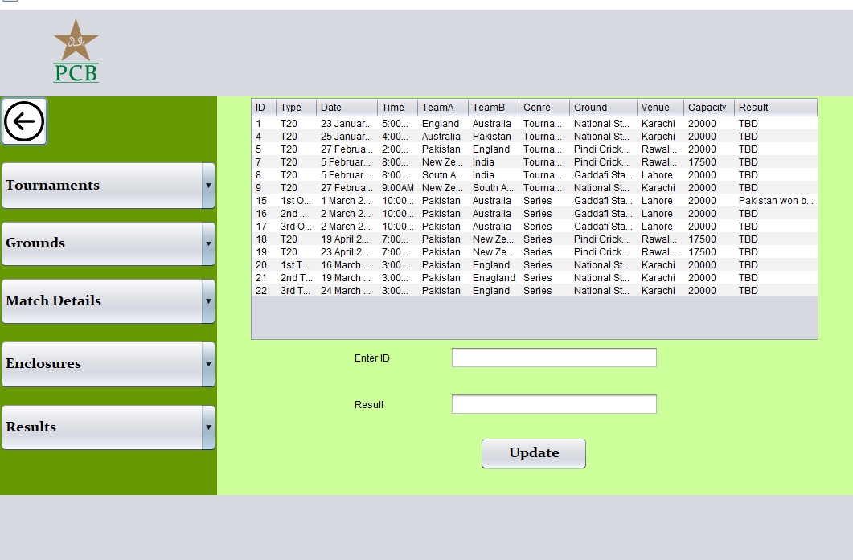

**Figure 4.23-** showing table which reads match details from database and displays in GUI.

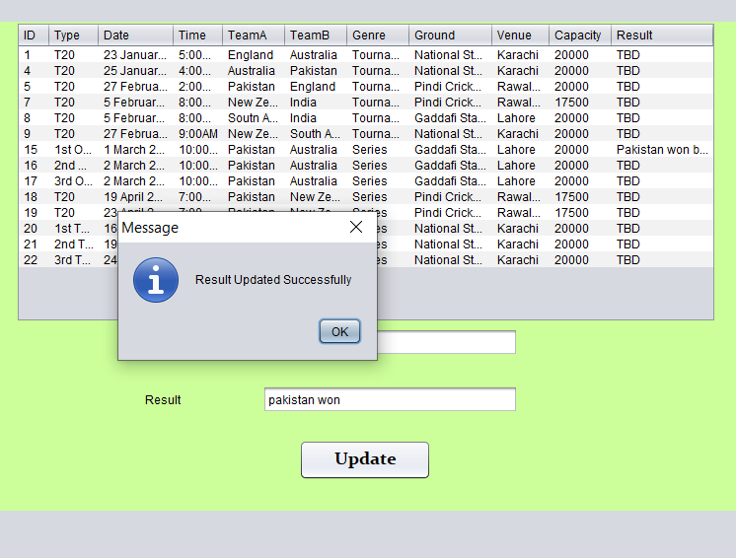

**Figure 4.24-** sows that the result has been updated successfully in database.

**Winner:**

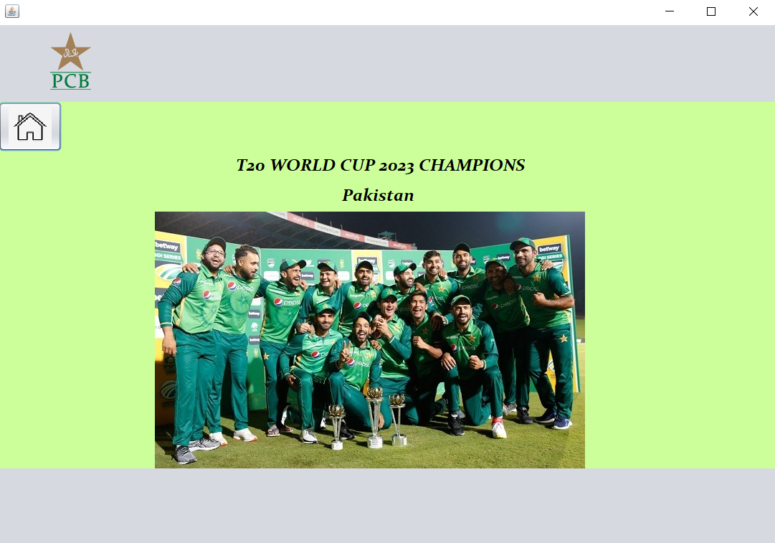

**Figure 4.25-** The picture of the winner team will be displayed along with the name.

**Knockout Stage:**

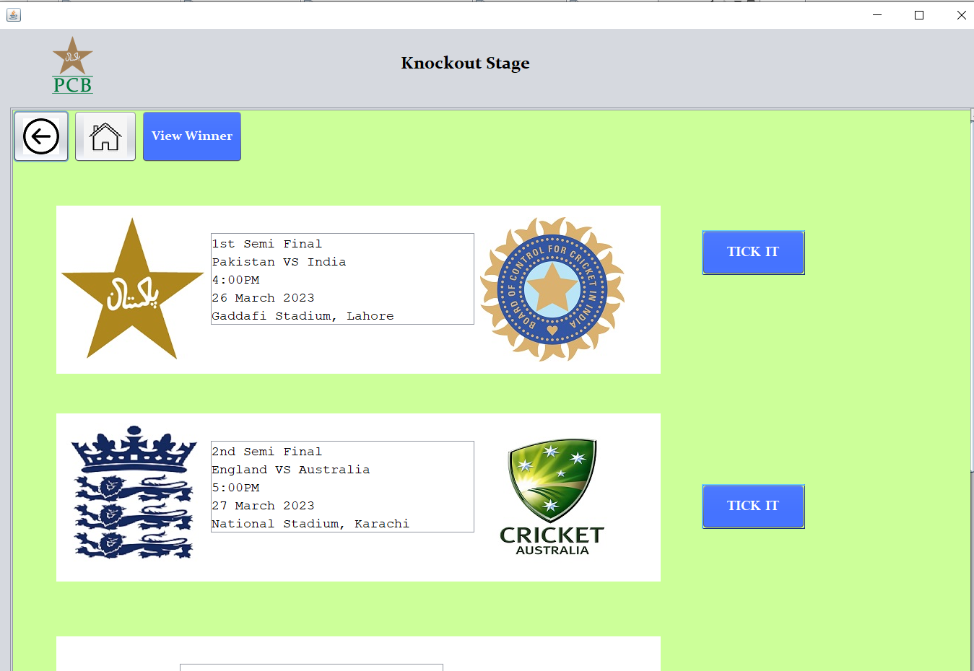

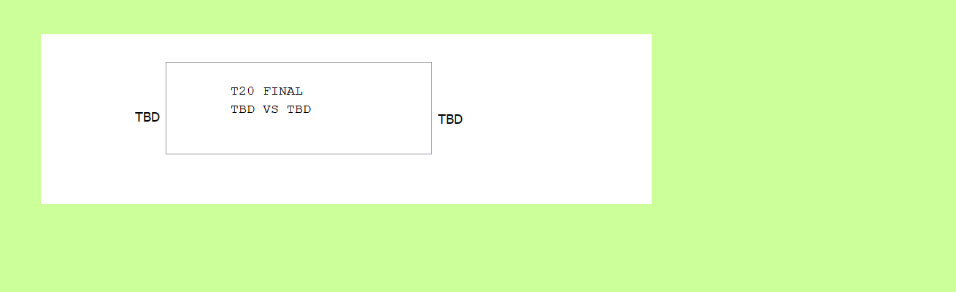

**Figure 4.26-** The final team for knockout will be shown.

**Database (Match Details):**

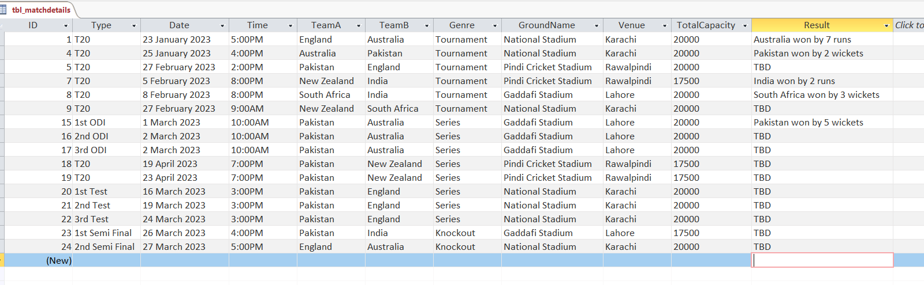

**Figure 4.27-** Shows the data base table of match details

1. **CODE SNIPPETS:**

* Enclosure Class:

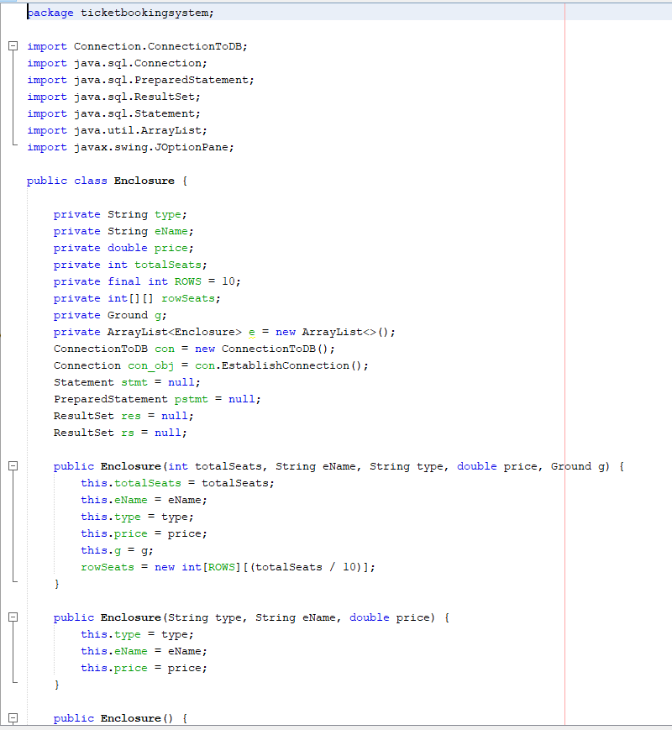

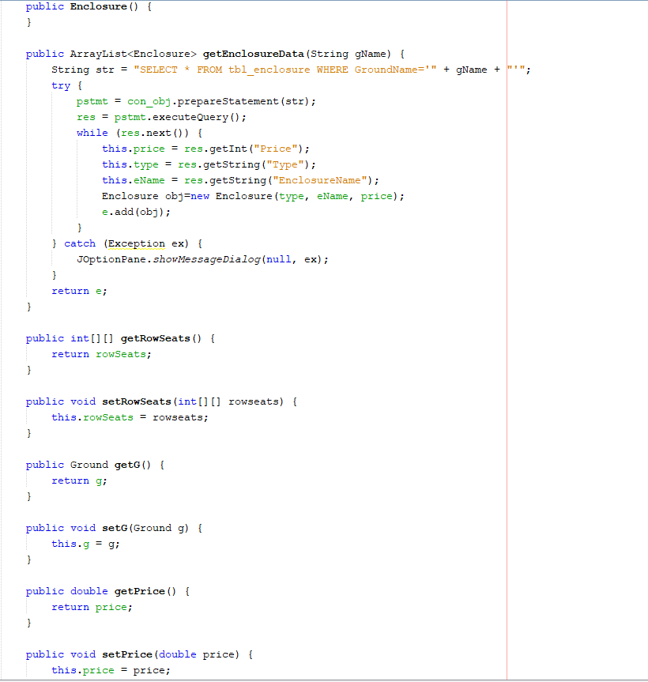

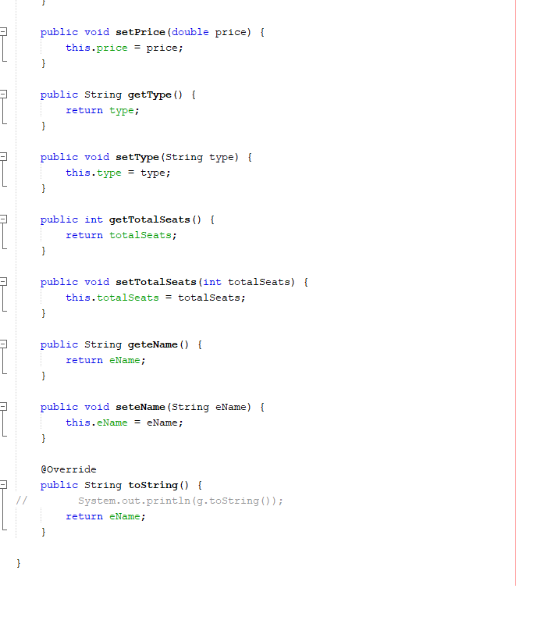

* Ground Class:

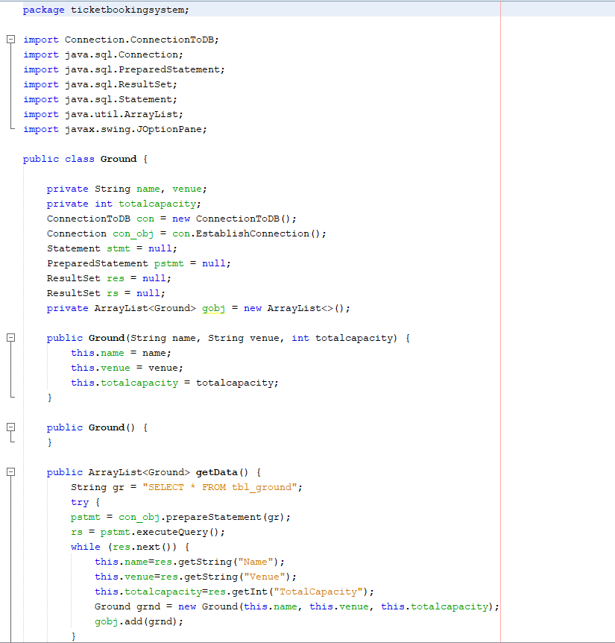

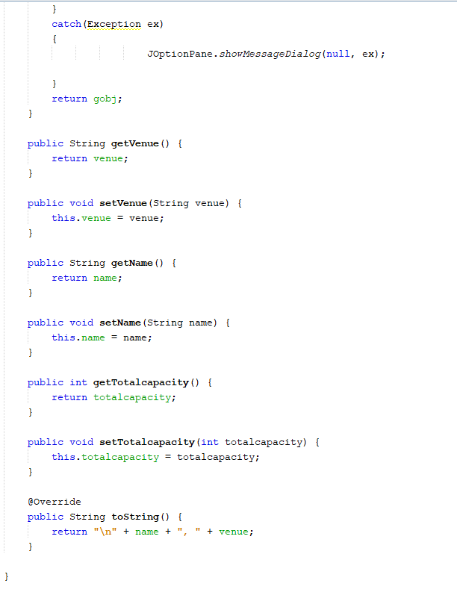

* Groups Class:

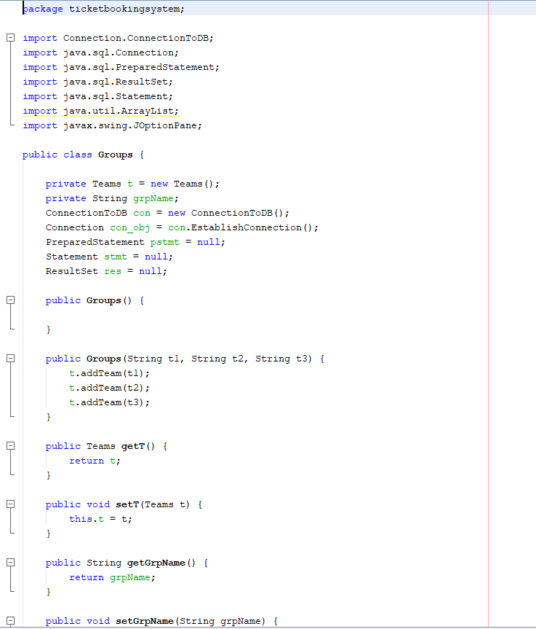

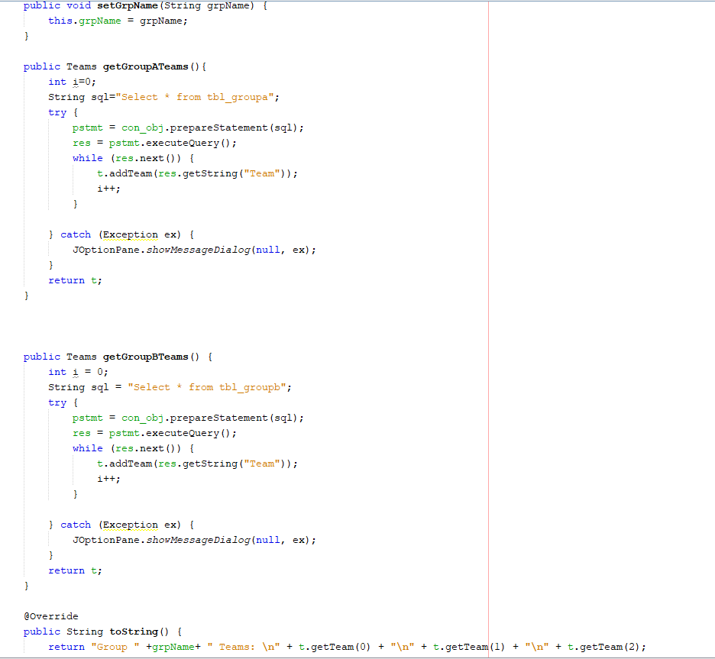

* MatchDetails Class:

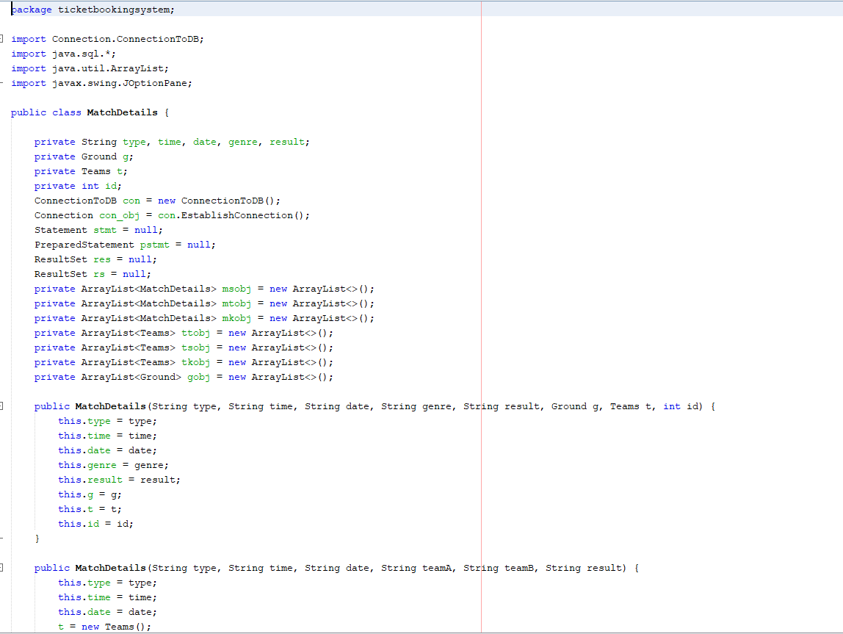

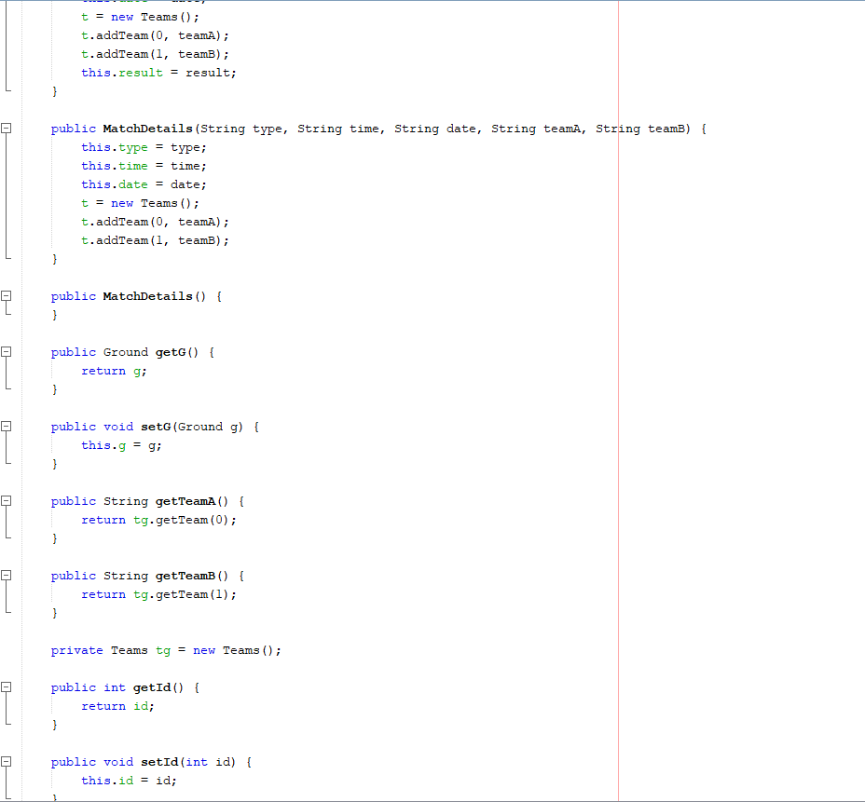

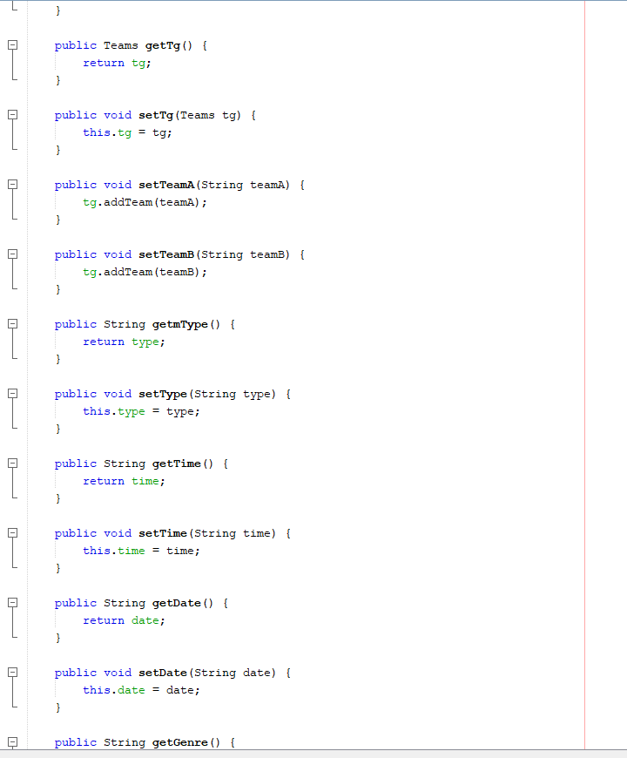

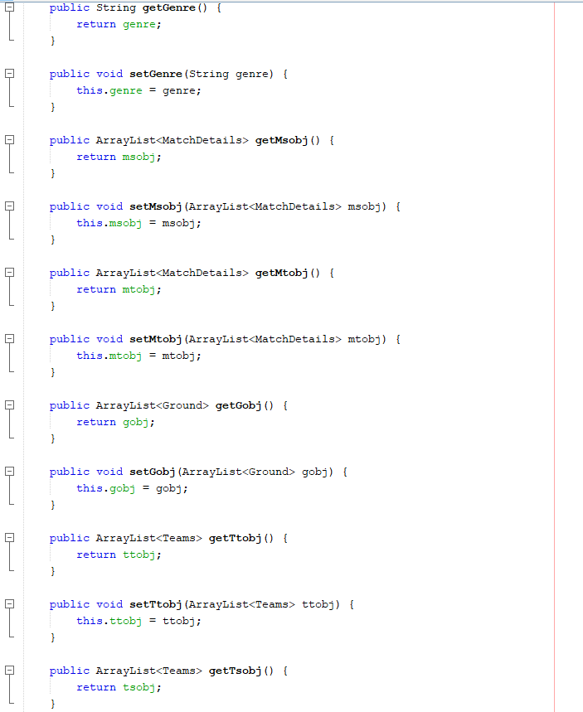

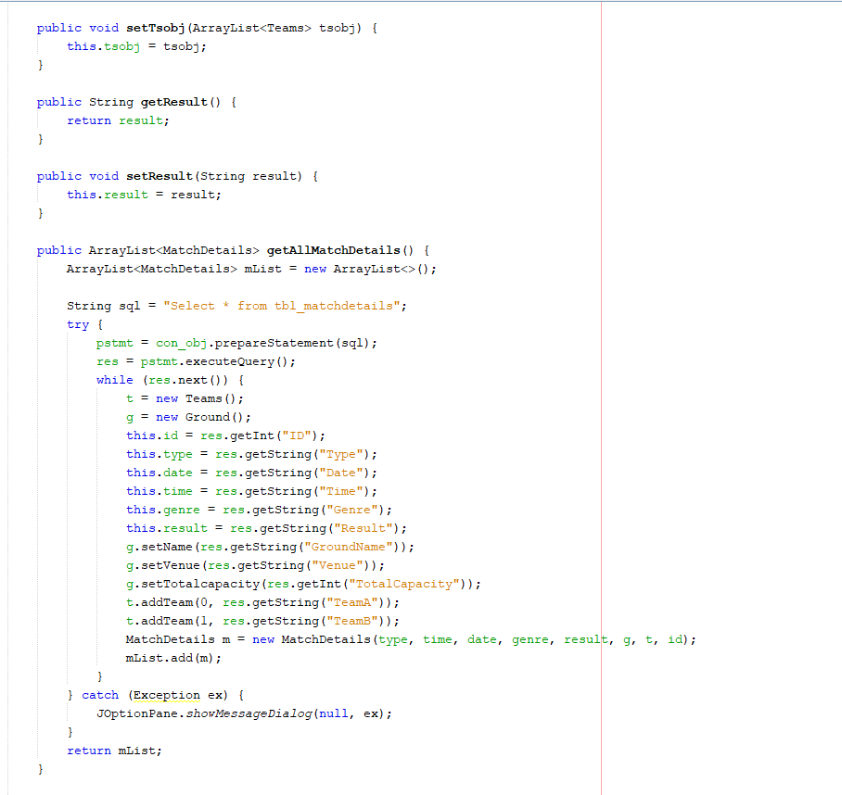

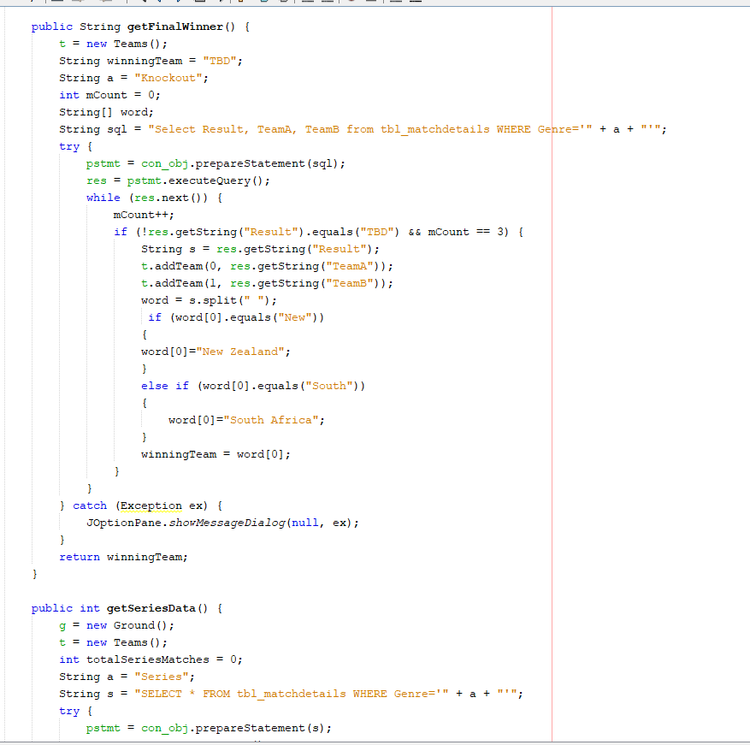

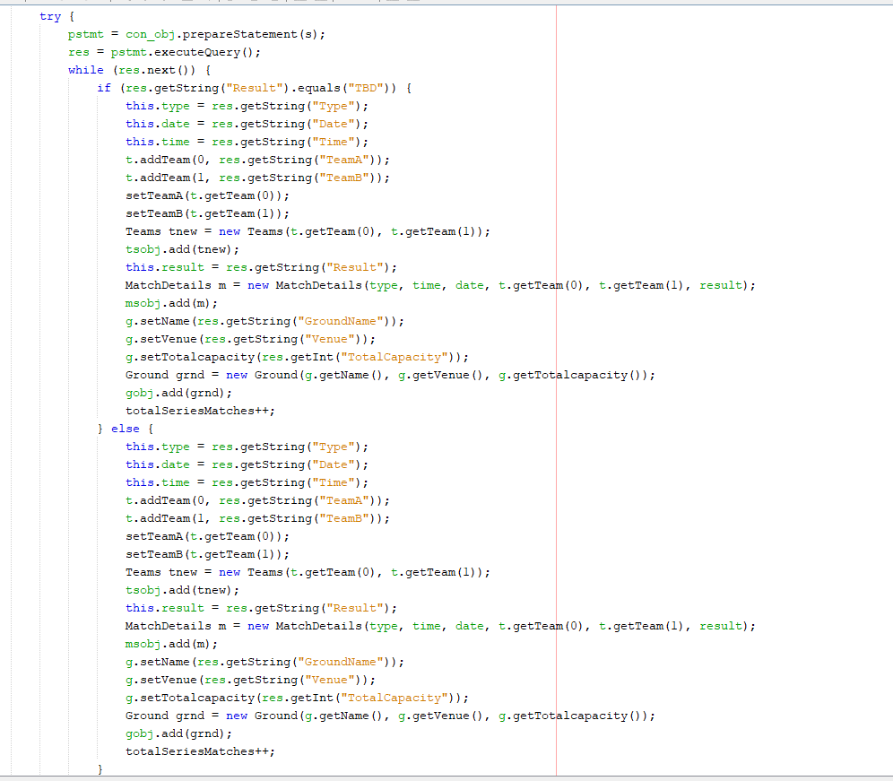

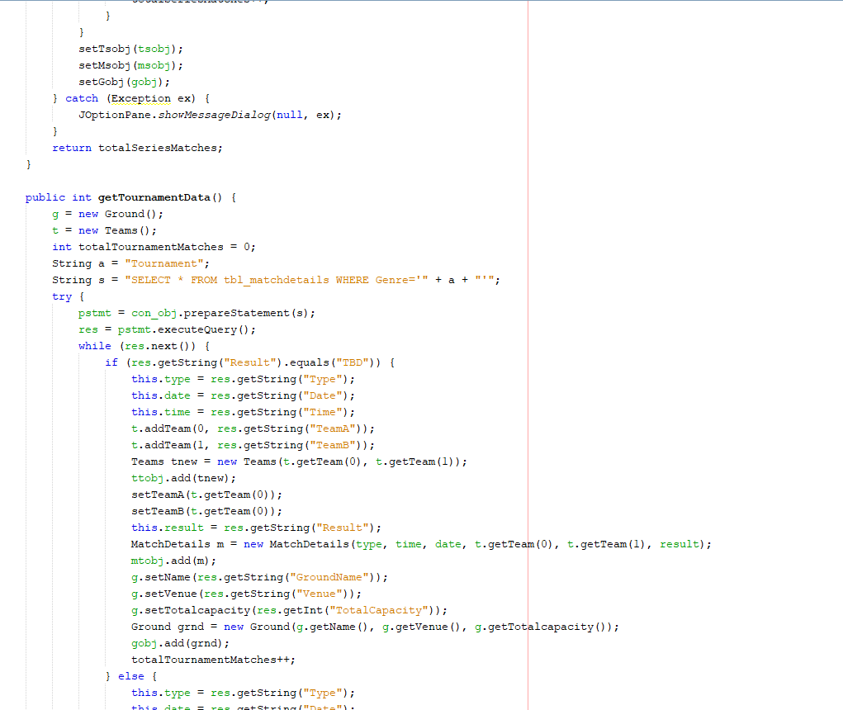

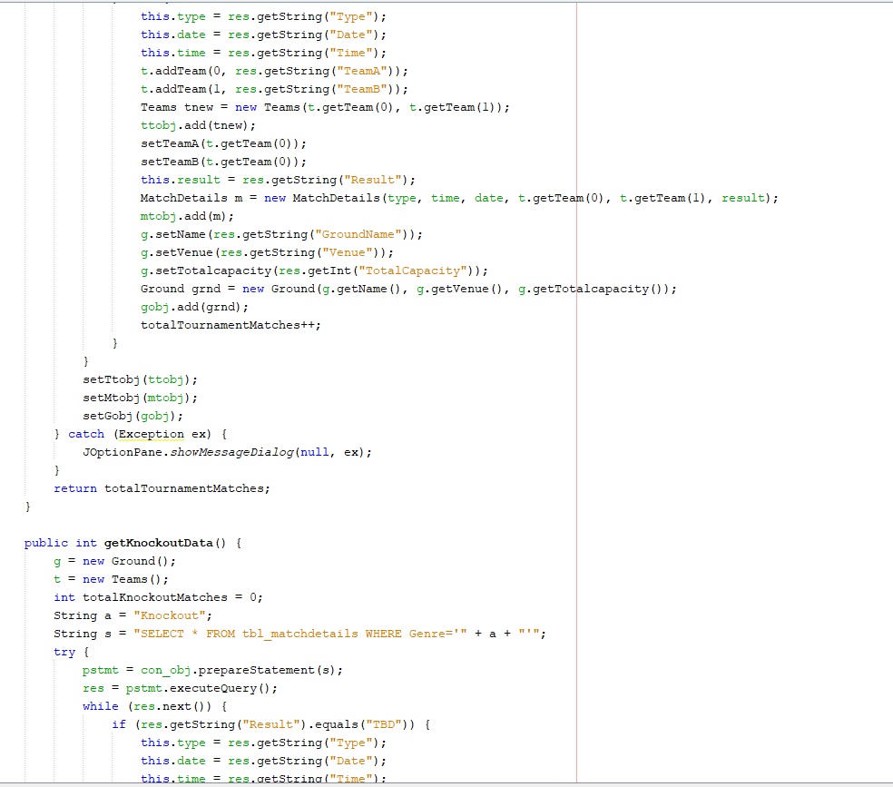

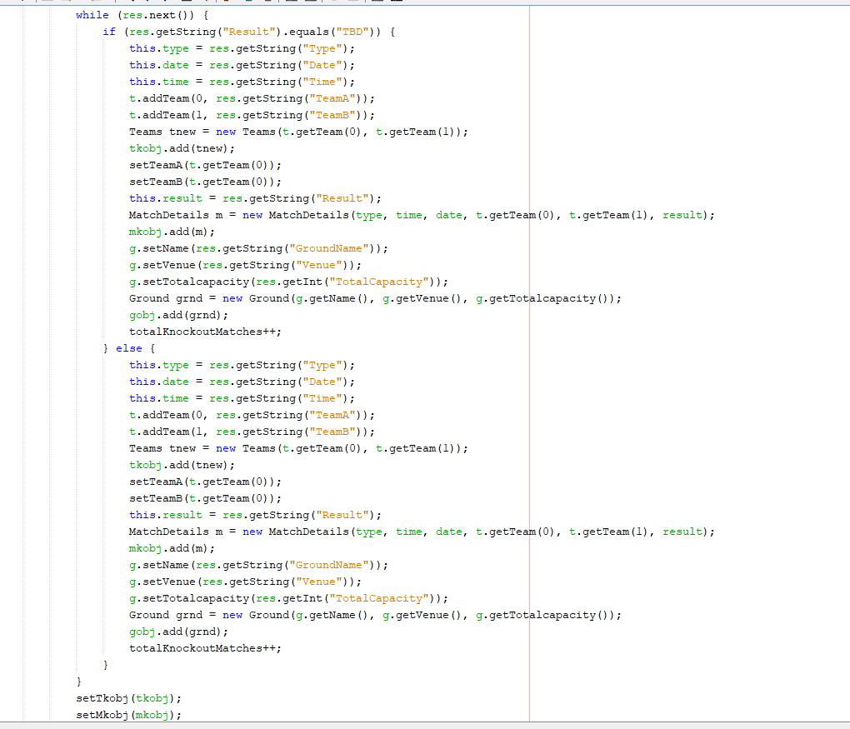

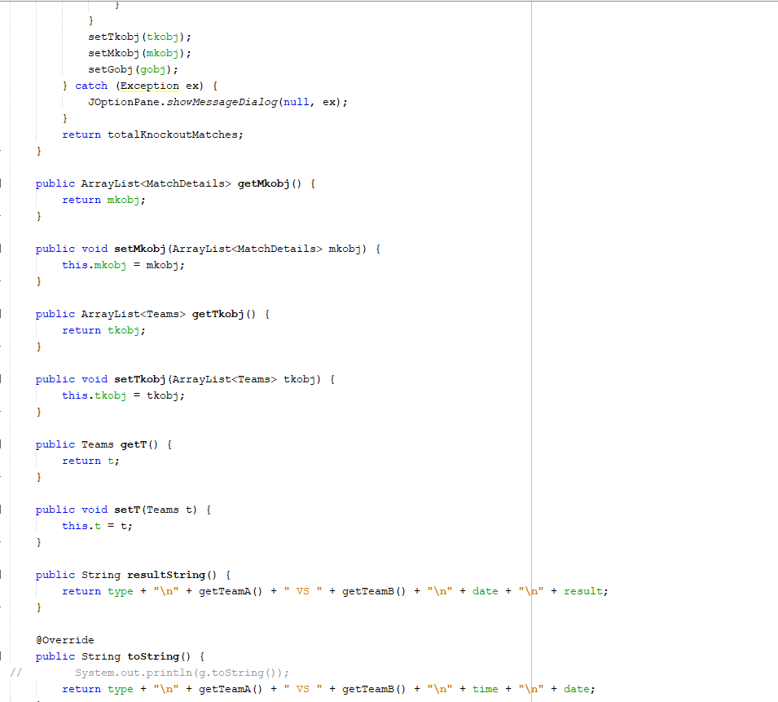

* Payment Method Class:

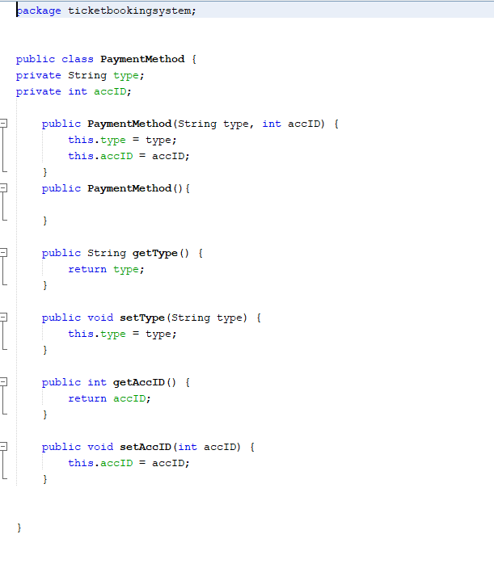

* PointsTable Class:

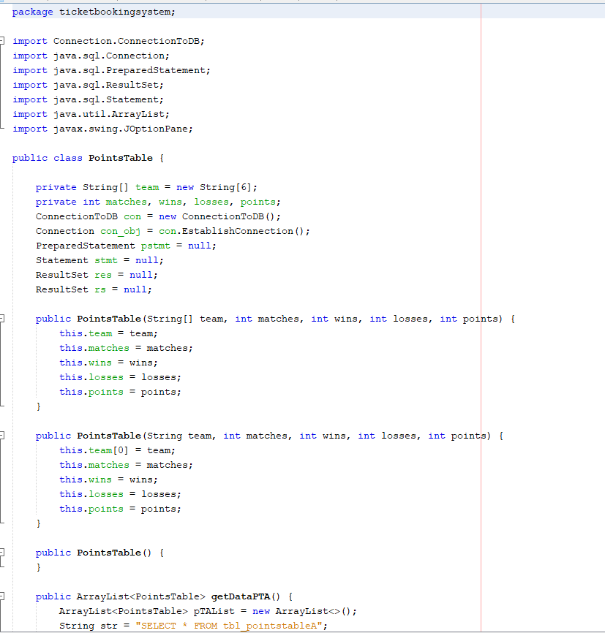

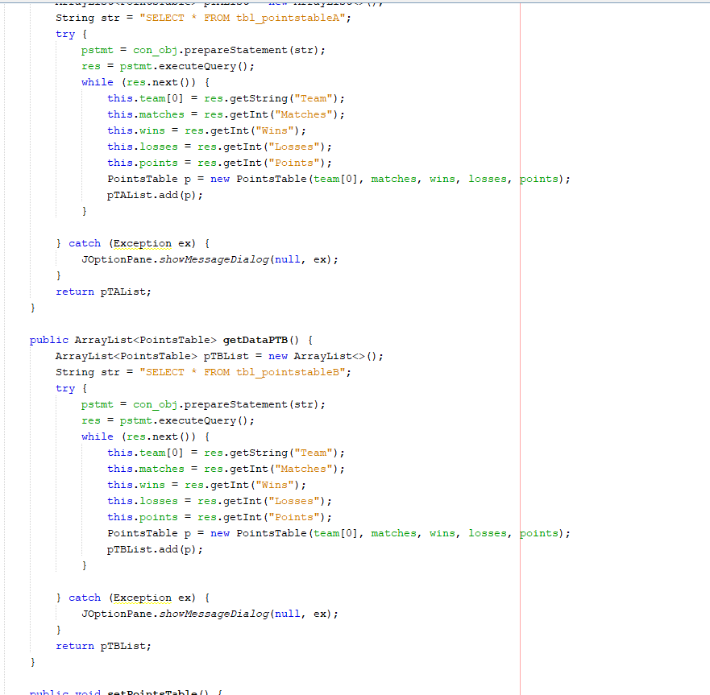

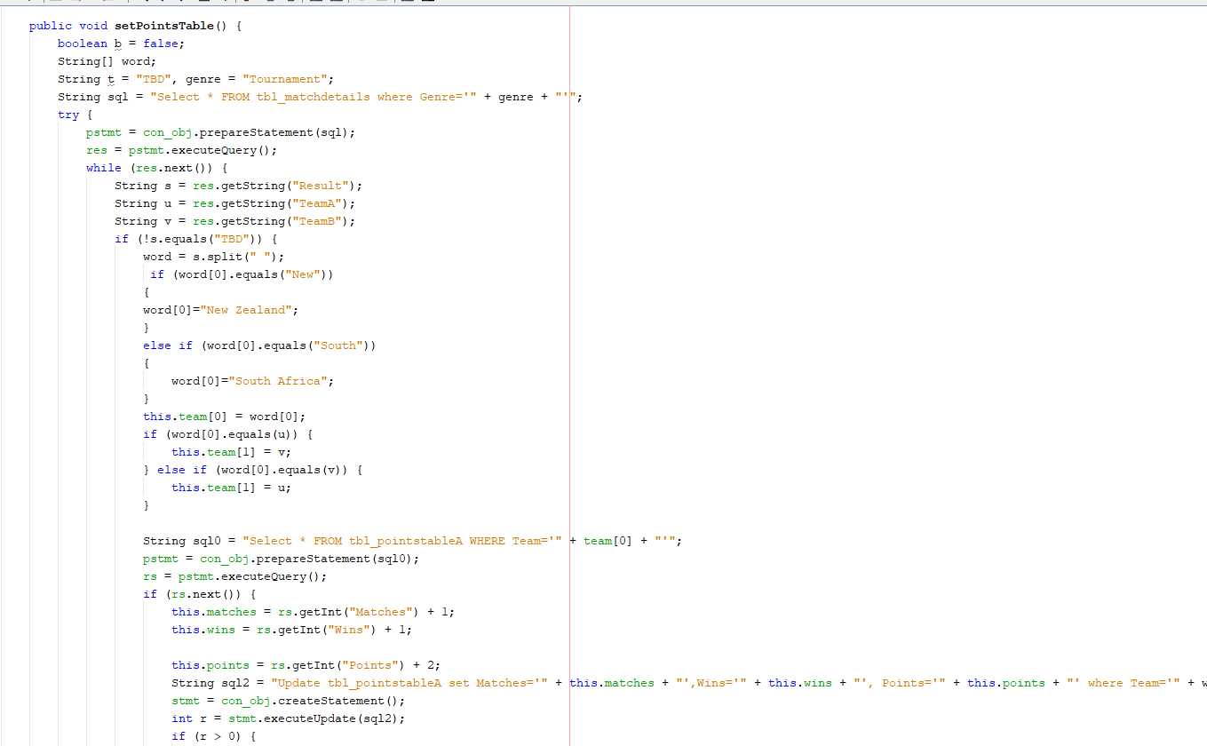

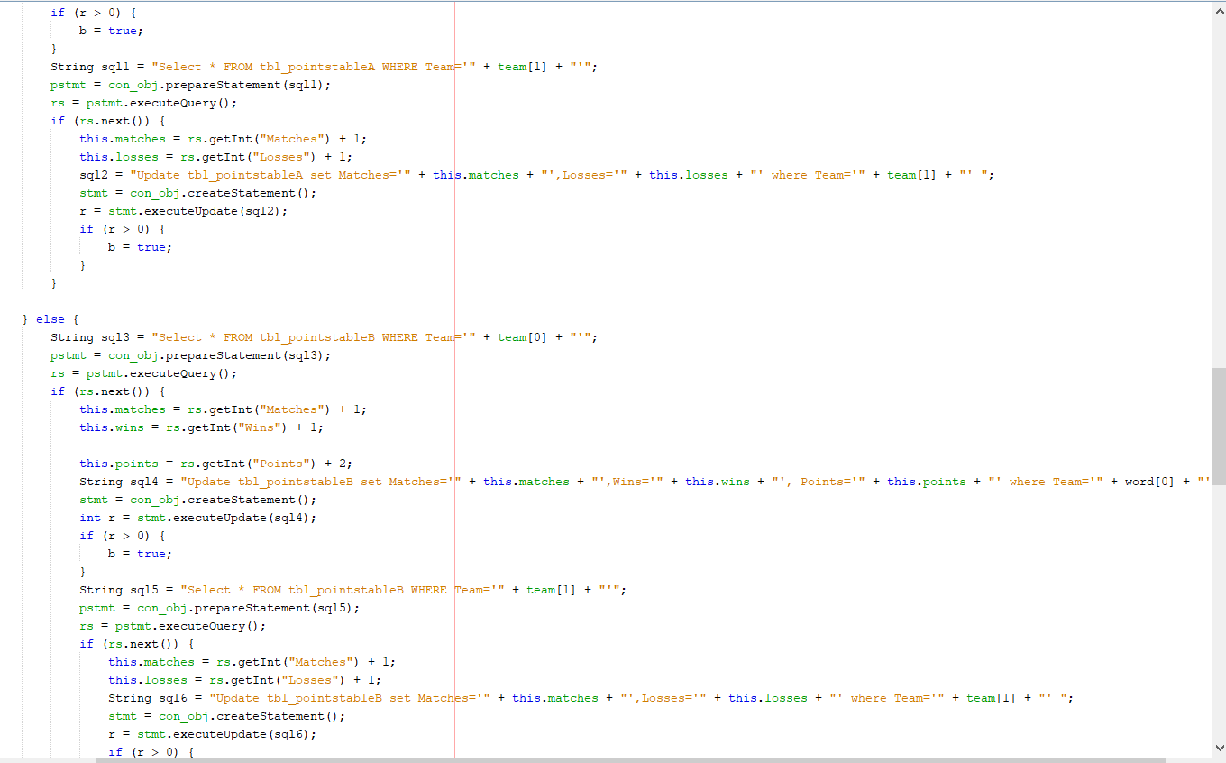

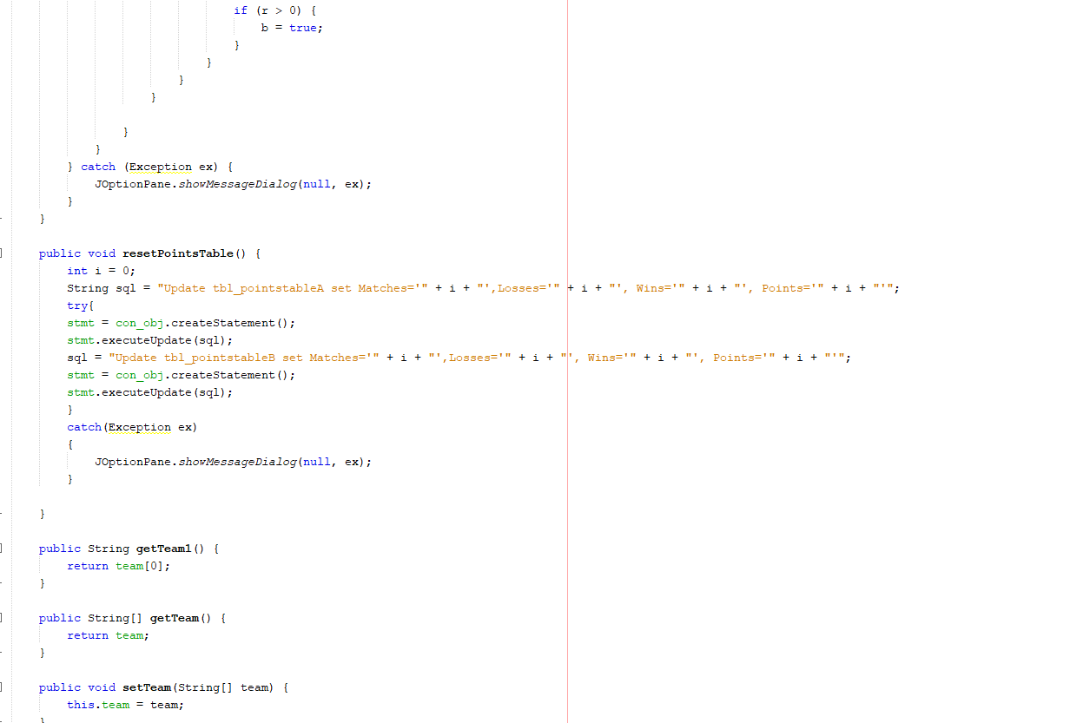

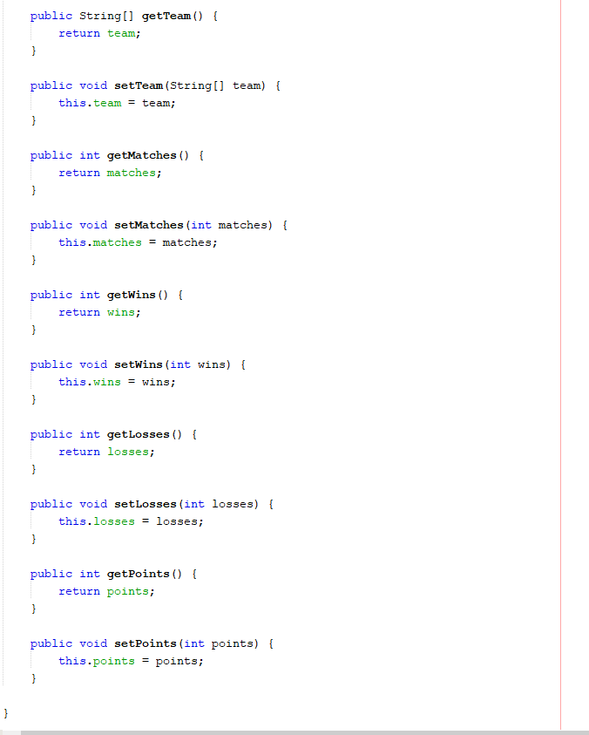

* Teams Class:

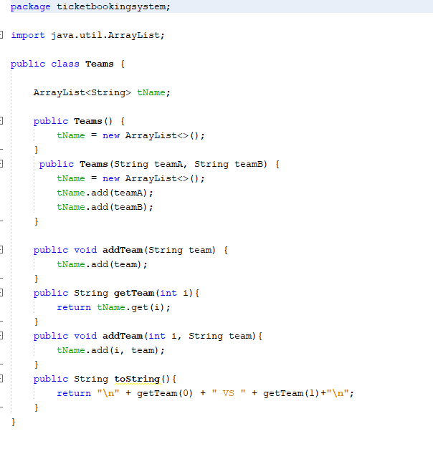

* Ticket Class:

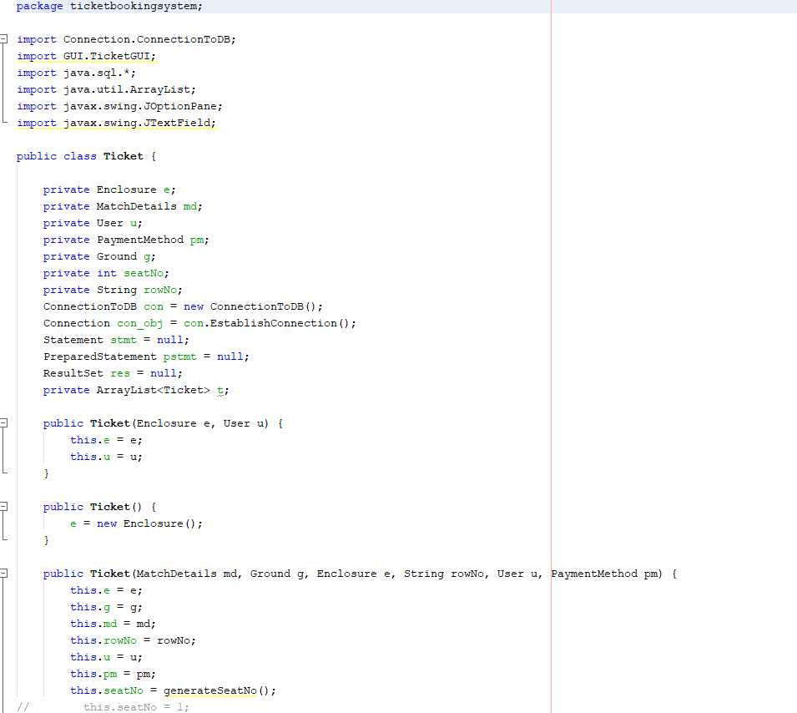

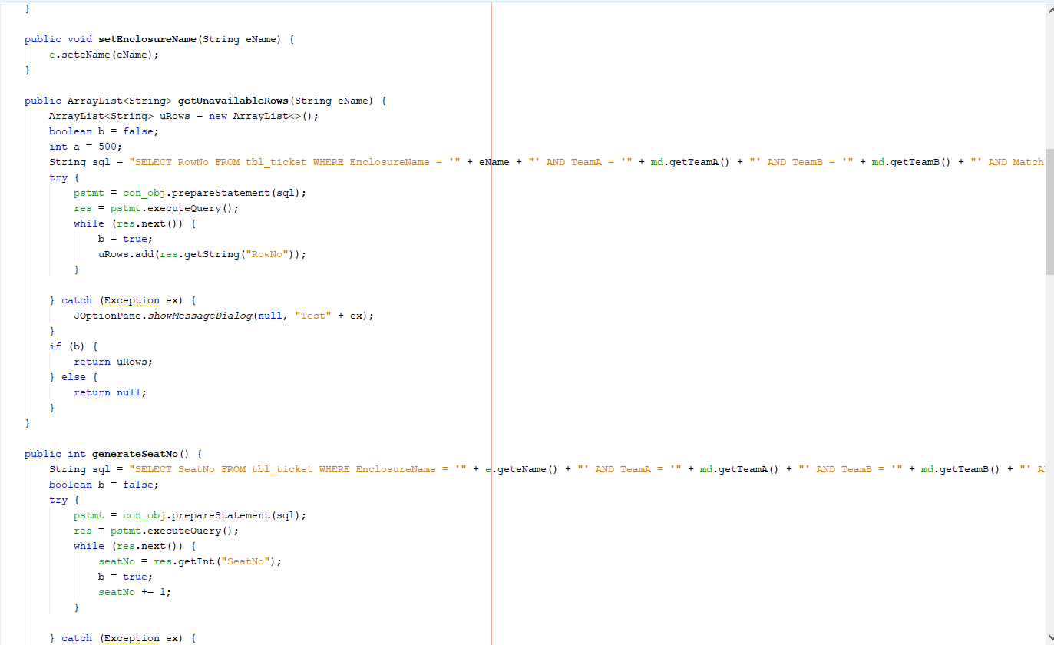

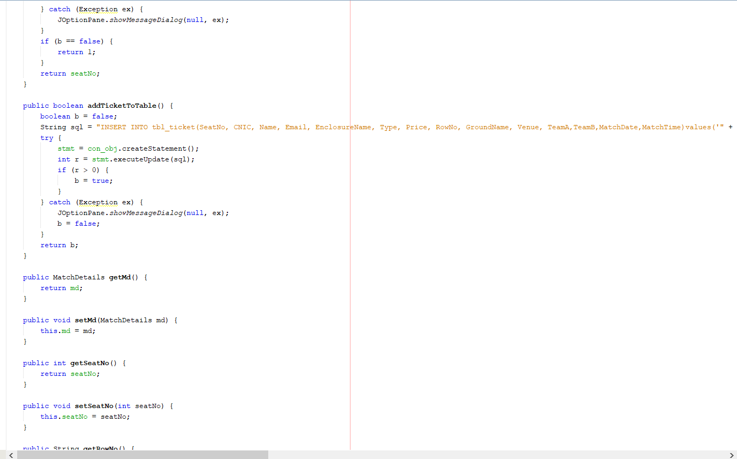

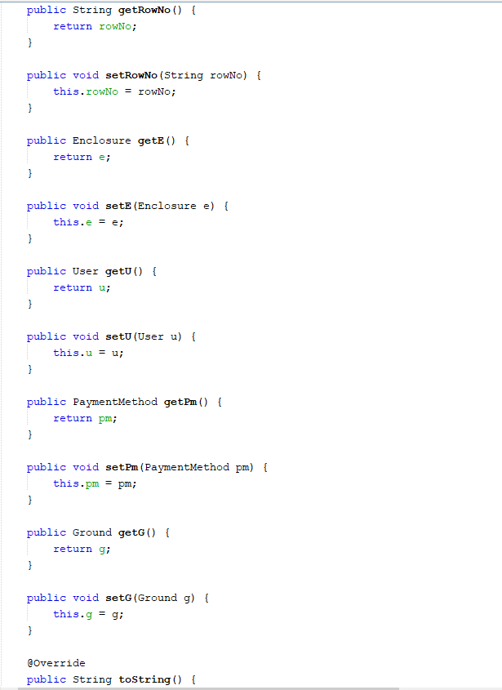

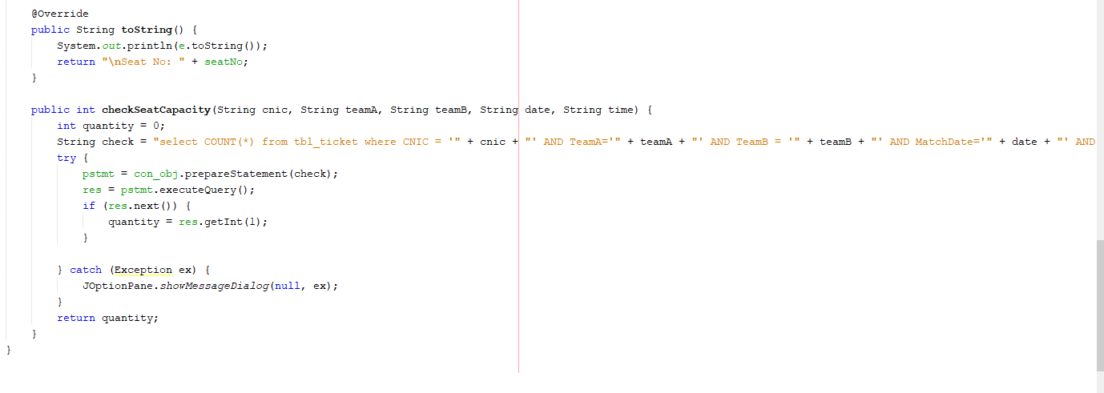

* Tournament Class:

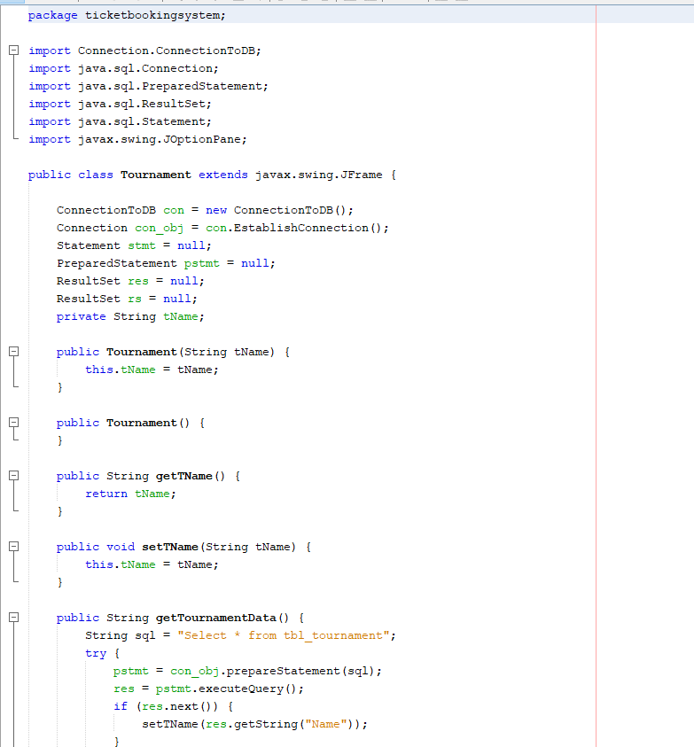

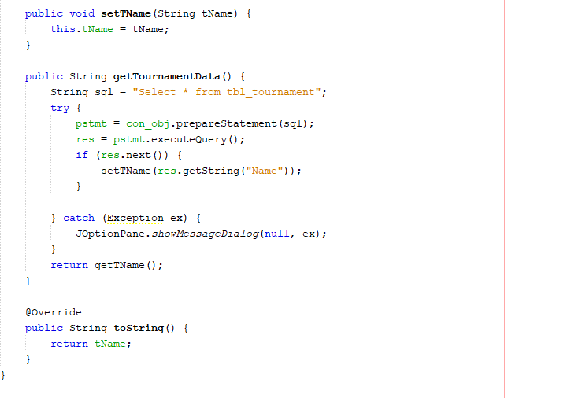

* User Class:

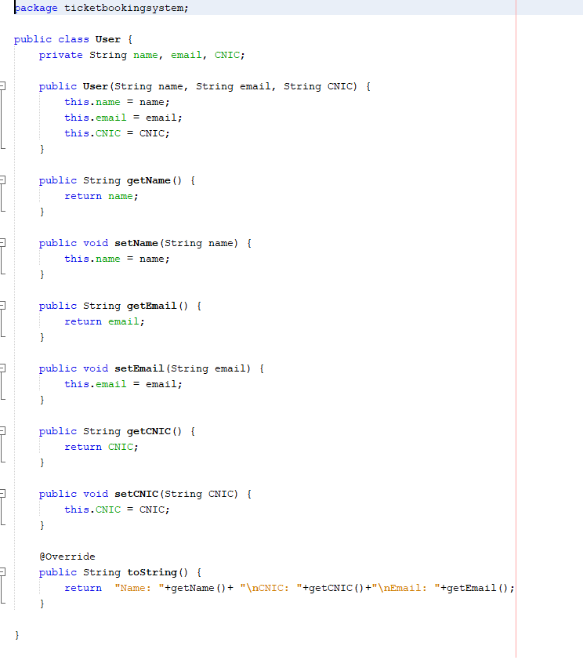

1. **CONCLUSION**

The Match ticket reservation system helps in minimizing the time taking work of manual ticket reservation, which is a hassle and consumes a lot of time that can be utilized somewhere else. The Match Ticket Reservation and Cancelling System was created in an effort to reduce the user's workload, get rid of all the paperwork, and save time. The system was created in such a way as to be exceedingly user-friendly. This system can be operated without difficulty by anyone who has some window-based experience.